# ****Donther E-Bike: Revolutionizing Electric Mobility****

**Submitted by:** Mohammed Aftab Vali & Team Tech Beasts  
**Institution:** Bellary Institute of Technology and Management  
**Funding Support:** ₹50,000 (Provided by the College for Project Implementation)

## ****1. Introduction****

The Donther E-Bike project aims to redefine the concept of electric mobility by addressing the major challenges in Electric Vehicle (EV) adoption. With a unique fusion of design, performance, and sustainability, Donther stands as the world’s most efficient e-bike, capable of achieving a range of **300–400 km per full charge**.  
This innovation is powered by **dual battery packs**, **regenerative braking**, and **integrated solar charging**—making it a true pioneer in green transportation.

## ****2. Problem Statement****

Despite growing interest in EVs, several roadblocks hinder their widespread adoption:

* **Range Anxiety** – Limited battery range makes users hesitant for long journeys.
* **Inefficient Braking** – Energy is lost during deceleration in traditional braking systems.
* **Lack of On-the-Go Charging** – Riders depend heavily on grid charging without renewable alternatives.

## ****3. Donther: The Integrated Solution****

Donther addresses these challenges through an integrated hardware and software approach:

### ****3.1 Dual Battery Packs****

* Two independent battery packs for redundancy and extended range.
* Automatic switching ensures uninterrupted power delivery.

### ****3.2 Project-D: Regenerative Braking****

* Recovers 10–20% of kinetic energy during braking.
* Extends range to the 300–400 km mark.
* Reduces wear on mechanical brakes.

### ****3.3 Passive Solar Charging****

* Top-mounted solar panels contribute 8–12% additional charge.
* Charges whether the bike is moving or parked.
* Reduces dependency on grid electricity.

### ****3.4 Smart Battery Management System (BMS)****

* Manages dual packs independently.
* Optimizes charging from solar and grid.
* Balances battery health to prolong lifespan.

### ****3.5 Integrated IoT Dashboard****

* Displays real-time ride metrics, navigation, and security alerts.
* Mobile app connectivity for customization and GPS tracking.
* Advanced anti-theft protection.

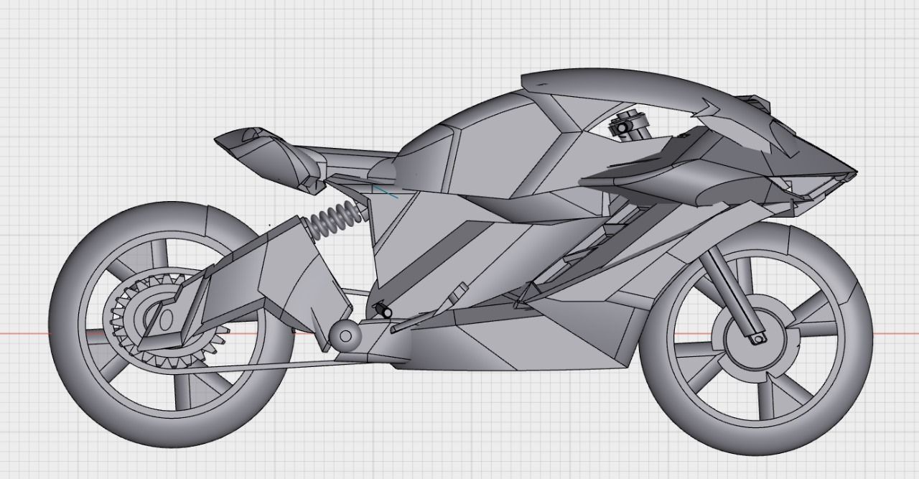

## ****4. System Architecture Overview****

The Donther E-Bike integrates:

* **BLDC Motor** for high-efficiency drive.
* **Custom BMS** for battery optimization.
* **Controller** for power regulation.
* **Solar Charging System** for renewable energy.
* **IoT Dashboard & App** for user control.

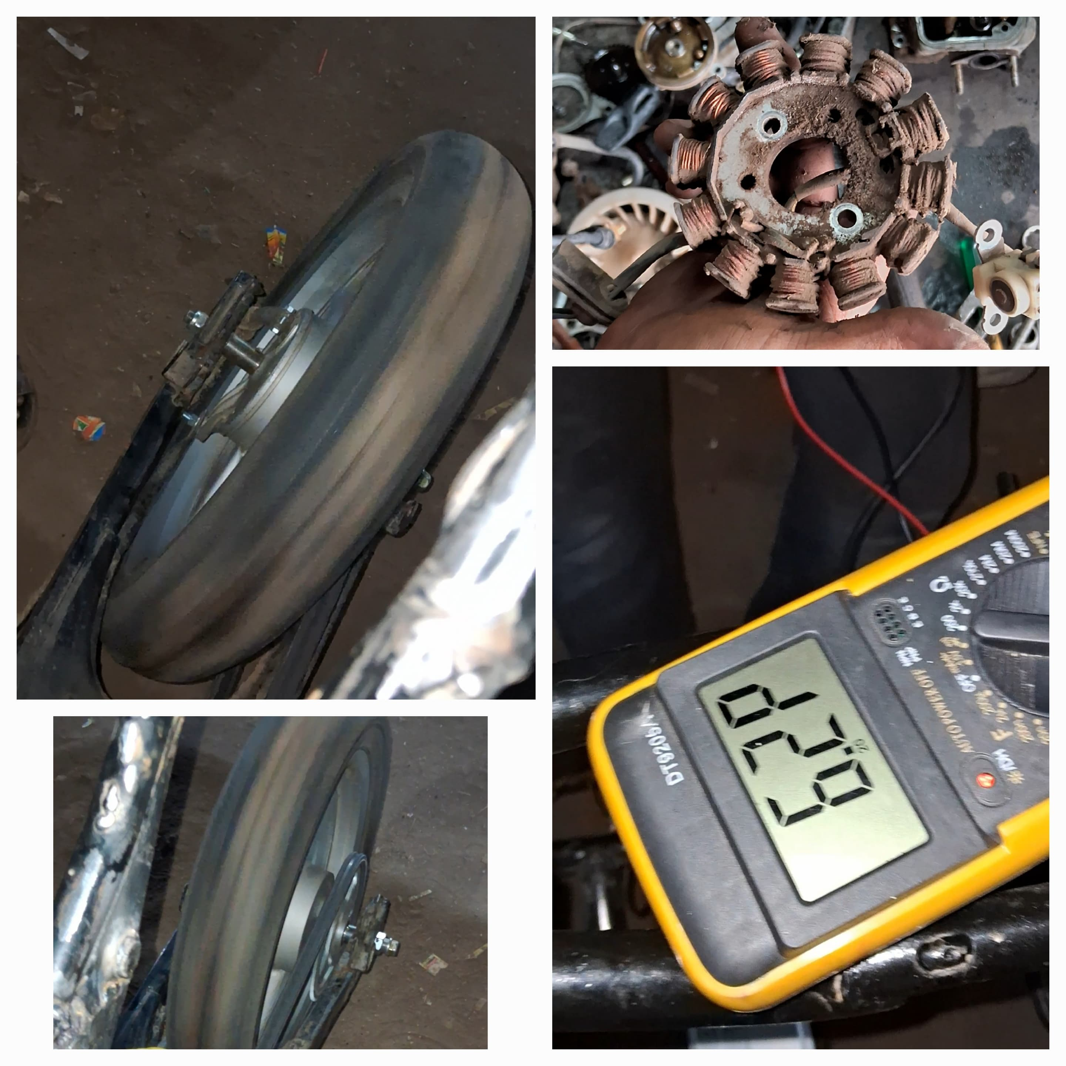

## ****5. Sustainability & Impact****

* **CO₂ Reduction:** Significant decrease in emissions compared to fuel-based transport.
* **Versatile Applications:** Urban commuting, last-mile delivery, rural transport, and even military logistics.
* **Quiet Operation:** Reduces noise pollution.

## ****6. Funding Support****

The Donther E-Bike project was funded with ₹50,000 by the Bellary Institute of Technology and Management.  
The allocated funds were utilized for:

| **Component** | **Cost (₹)** |
| --- | --- |
| Battery procurement and fabrication | 22,000 |
| Solar charging system components | 10,000 |
| BLDC motor and controller | 8,000 |
| IoT and dashboard development | 5,000 |
| Frame modification and assembly | 5,000 |

## ****7. Conclusion****

The Donther E-Bike is not just a product—it is a movement towards sustainable, efficient, and long-range electric mobility. With its innovative features, the Donther addresses the most critical EV challenges, paving the way for eco-friendly transportation in both urban and rural settings.

## ****8. References****

* Project-D internal documentation
* IoT module design guidelines
* Solar energy integration research papers